
HOW TO MAKE INCLUSIVE TRAININGS
SAFETY INCLUDED 2026

- Accessibility and DEI resources:
  - While Presenting:
    - Identify and Describe Speaker(s)
    - Speak clearly, and avoid speaking too fast
    - Use simple language. Avoid or explain jargon, acronyms, and idioms.
    - Give people time to process information. Pause between topics.
    - Be visible - Be careful not to face away from the audience to read projected material.
    - Ensure all relevant sound is audible through the sound system. For example, if the audience doesn’t have a microphone, repeat their questions and comments into your microphone before replying.
    - Describe pertinent parts of graphics, videos, and other visuals - Describe them to the extent needed to understand the presentation. (You usually do not need to describe decorative images.)
    - Describe other visual information. For example, a speaker asks people to raise their hands if they make their websites fully accessible. The speaker should then describe the visual response: “About half raised their hand”. ix. Read more here
  - Be sure to use proper disability language. Language around disability should be neutral and not laden with value judgments or adjectives that are negative. Review the Language Guidelines below for more information.
  - Make your PowerPoint accessible:
    - Make text and important visuals big enough to be read even from the back of the room. This includes graphics on slides, videos, posters, and other nonelectronic material.
    - Use an easy-to-read font face.
iii. Read more here if you wish: Link iv. Visual Accessibility 1
v. Visual Accessibility 2

- Language Guidelines:
Language around disability should be neutral and not laden with value judgments or adjectives that are negative.

Find other ways to describe what you mean:
- High functioning/low functioning or, Low Support Needs/High Support Needs. Focus on specific needs or traits like in the diagram below does.
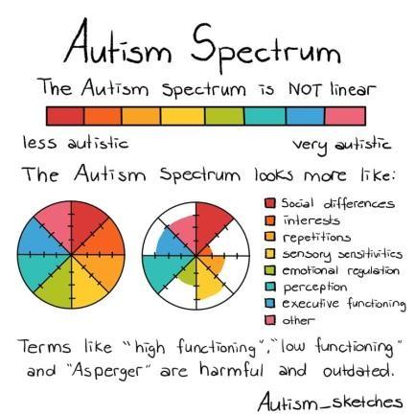

Language around disability should focus on how someone does something not around the way they cannot do things. For example:

Mike uses a wheelchair instead of Mike can’t walk

This document is being updated as feedback is given throughout the year. This has been updated December 2025.

