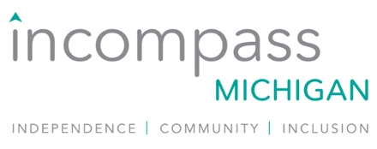

**Member Referral Program**

**Program start date:** January 1, 2025

**Eligibility:** Current Incompass Michigan Organizational and Associate members can earn incentives by helping to recruit new members to join the Association.

**Make a Connection**

* Know an organization that is not currently an Incompass Michigan member and would make a great addition to the Association? Share your perspective on membership value with them and invite them to a meeting with you and a member of the Incompass Michigan leadership team to discuss their interest in learning more about joining.
* Need help identifying an organization to invite? We have a leads list of 160+ organizations and can help you identify an organization to connect with.
* *Please let Todd or Laurie know who you intend to Connect with prior to initial contact so we can track outreach and ensure there isn’t overlap.

**Incentives**

* Receive a 50% conference discount on one registration to your choice of the Leadership Conference or re:con for each Connection Meeting you initiate (no limit on the number of discounted registrations you can earn).
  + Meeting must be with an organization eligible for either Associate or Organizational membership with the Association
  + Meeting must be with an individual at the organization who has decision making authority to join the Association
* If the Connection Meeting results in the organization applying for membership within 3 months, your conference registration becomes free! (choice of Leadership Conference or re:con)
* Bonus – if the organization applies to join the Association in Q1 (1/1-3/31) – you’ll receive one comped registration to the Leadership Conference AND one comped registration to re:con