CARES Act Provider Relief Fund – August 10, 2020
Stakeholder Toolkit

Dear Stakeholder,
Thank you for your support helping us get the word out about the Provider Relief Fund Program. We know health care providers across the nation are struggling to cope with the devastating effects of the COVID-19 pandemic. That’s why HHS is focused on administering the program in a way that is fast, transparent and fair so as many providers as possible can receive some financial support in this difficult time.
Below are resources you may use to raise the awareness about the provider relief fund among your members and networks. For additional resources, visit hhs.gov/providerrelief or email PRFCommunications@hrsa.gov.
Stakeholder Email
Social Media Content
[including webcast announcement]
Newsletter Content
Sample Stakeholder Email
Subject Line: Additional Funding Opportunity for COVID-impacted Health Care Providers
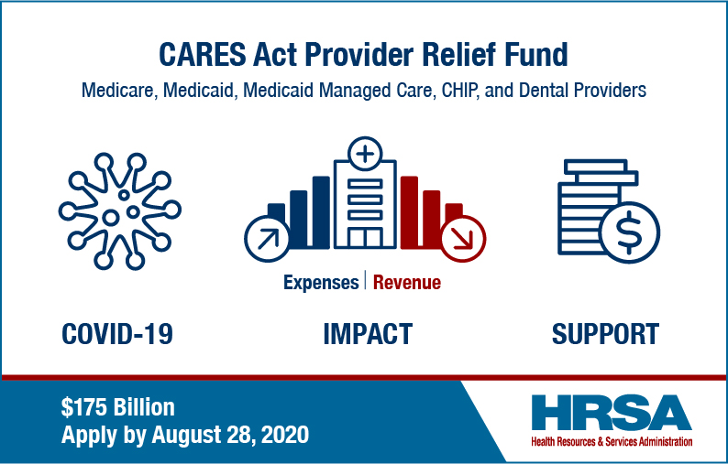
FINANCIAL SUPPORT FOR MILLIONS OF HEALTH CARE PROVIDERS NATIONWIDE
Up to 2% of patient revenue regardless of a previous disbursement.
Many health care providers are experiencing significant financial hardships in the COVID-19 pandemic. Congress provided $175 billion in relief funds to the U.S. Department of Health and Human Services (HHS) to deliver financial relief to hospitals and other health care providers, including those on the front lines of the coronavirus response. Since March, HHS, through the Health Resources and Services Administration (HRSA), has been distributing the funds to various providers in phases to support their increased healthcare-related expenses or lost revenue that are attributable to COVID-19; and to reimburse claims for the testing and treatment of uninsured individuals diagnosed with COVID-19.
The latest phase of funding is now available through August 28, 2020. Visit hhs.gov/providerrelief to learn more and get started with the application.
Who is eligible to apply?
- Providers who bill Medicare, Medicaid, Medicaid managed care, or CHIP
- Dental providers who accept insurance, as well as bill patients directly
- First-time or previous applicants may apply as long as they haven’t already received 2% of their patient revenue
How to apply?
- Follow the 6-Step Application Process
- Provider Relief Fund Application and Attestation Portal
- If you encounter challenges with the application, call the Provider Support Line at (866) 569-3522; for TTY, dial 711
Learn More…

###

Provider-Specific Sample Social Media
For higher resolution images email PRFCommunications@hrsa.gov.
General
Health care orgs & providers may be eligible to receive up to 2% of their patient revenue due to increased expenses or lost revenues attributable to COVID-19. See if you are eligible and apply by August 28, 2020. bit.ly/30zECa5 #providerrelieffund
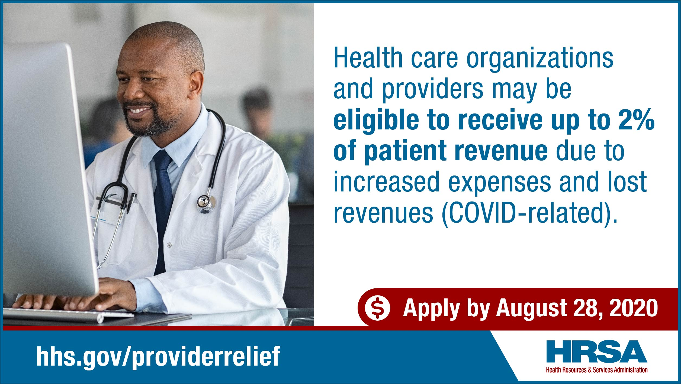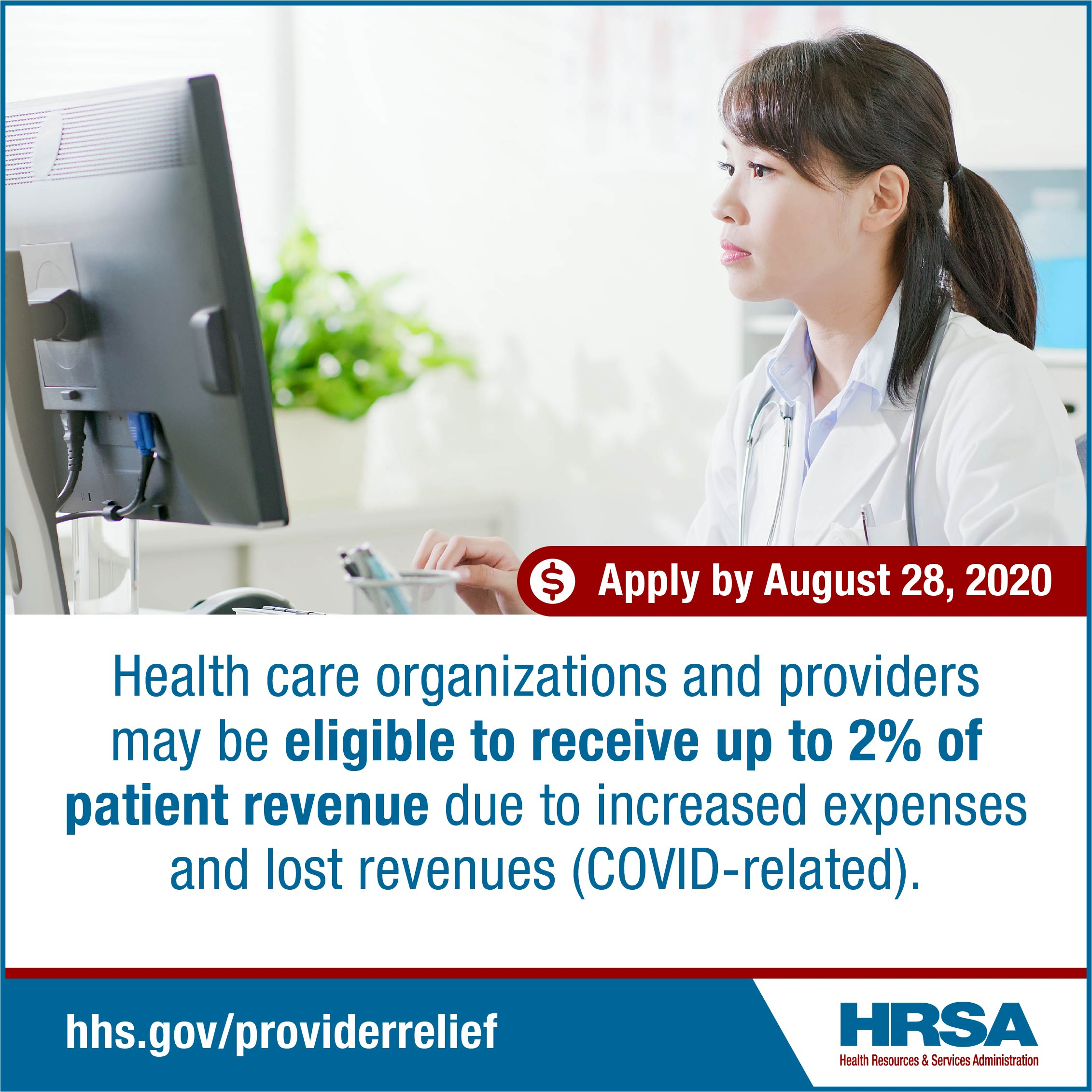
Medicaid
Bill Medicaid? You may be eligible to receive up to 2% of your patient revenue from the #providerrelieffund. Received funds already but missed your opportunity to apply for additional funding up to 2% of revenue? You may have another chance. Find out more and apply by August 28, 2020. bit.ly/30zECa5 #medicaidproviders
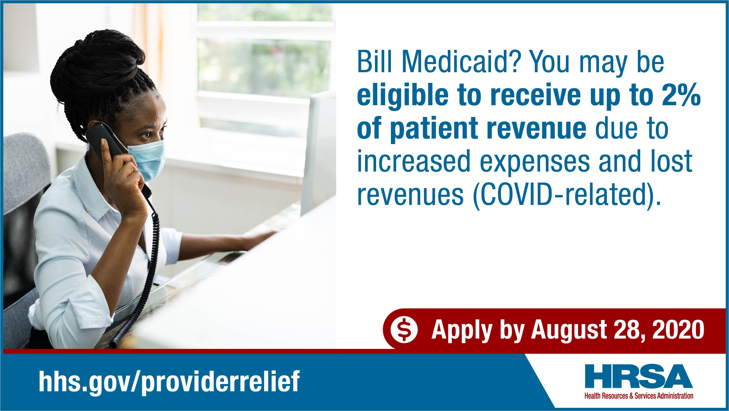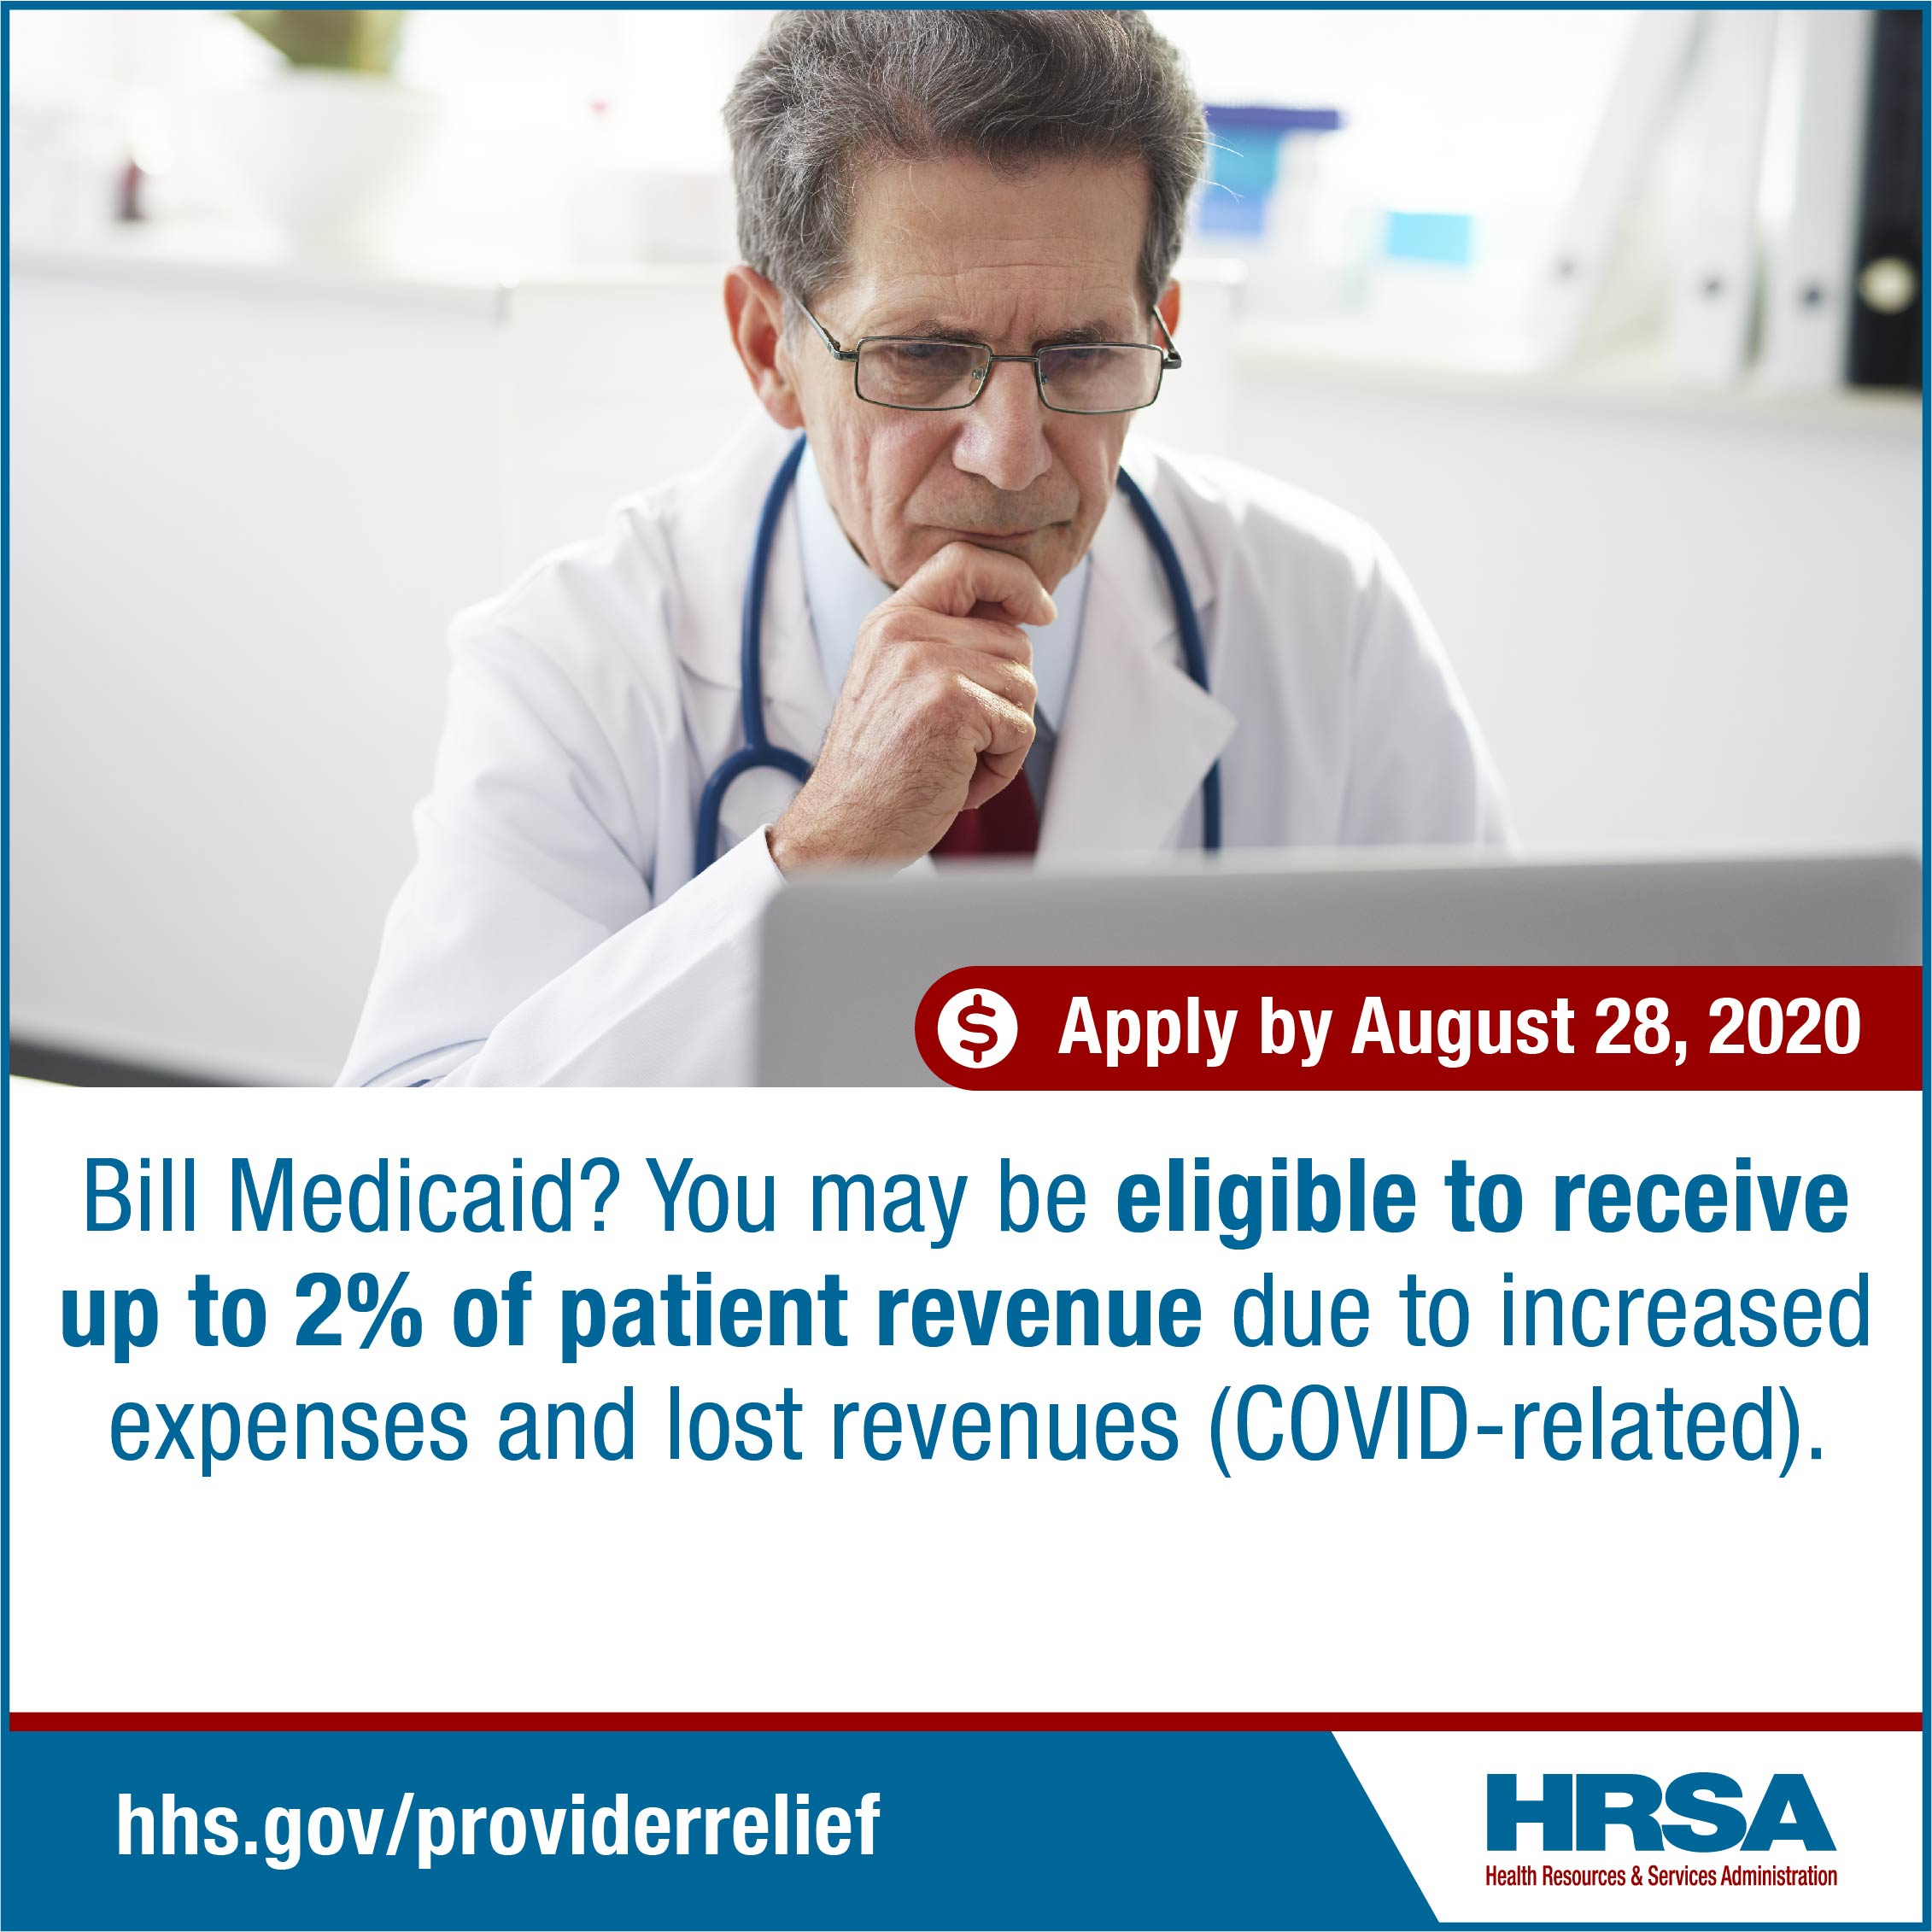

CHIP
Bill CHIP? You may be eligible to receive up to 2% of your patient revenue from the #providerrelieffund. Received funds already but missed your opportunity to apply for additional funding up to 2% of revenue? You may have another chance. Find out more and apply by August 28, 2020. bit.ly/30zECa5 #CHIPproviders
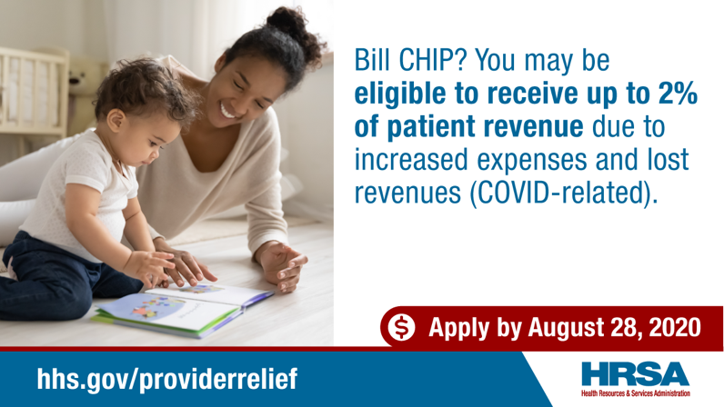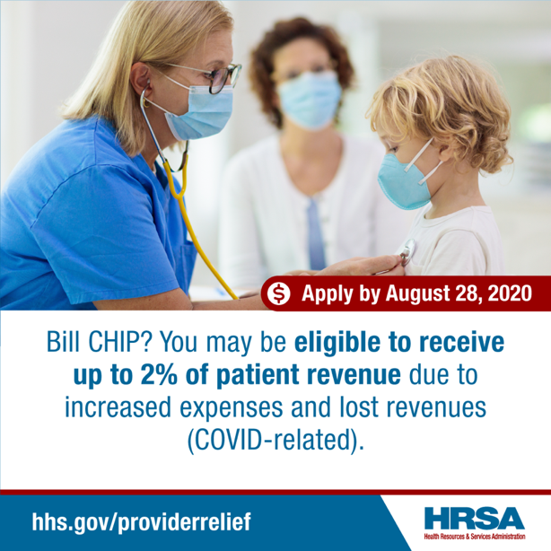

Home- and Community-Based
Home- and Community-Based Provider may be eligible to receive up to 2% of their patient revenue due to increased expenses or lost revenues attributable to COVID-19. See if you are eligible and apply by August 28, 2020. bit.ly/30zECa5 #providerrelieffund #HCBSproviders
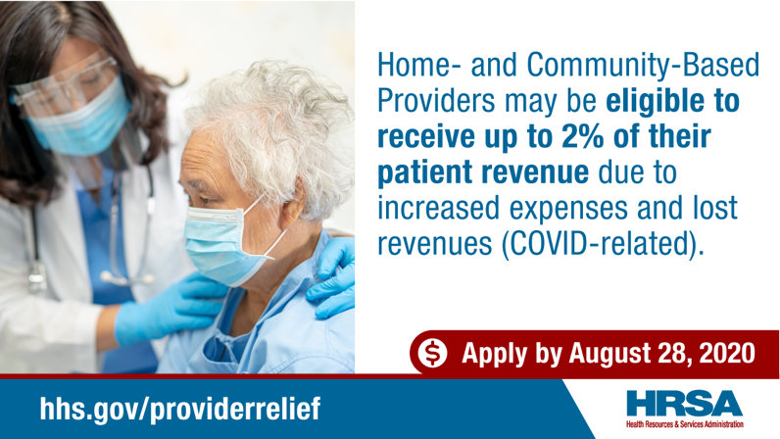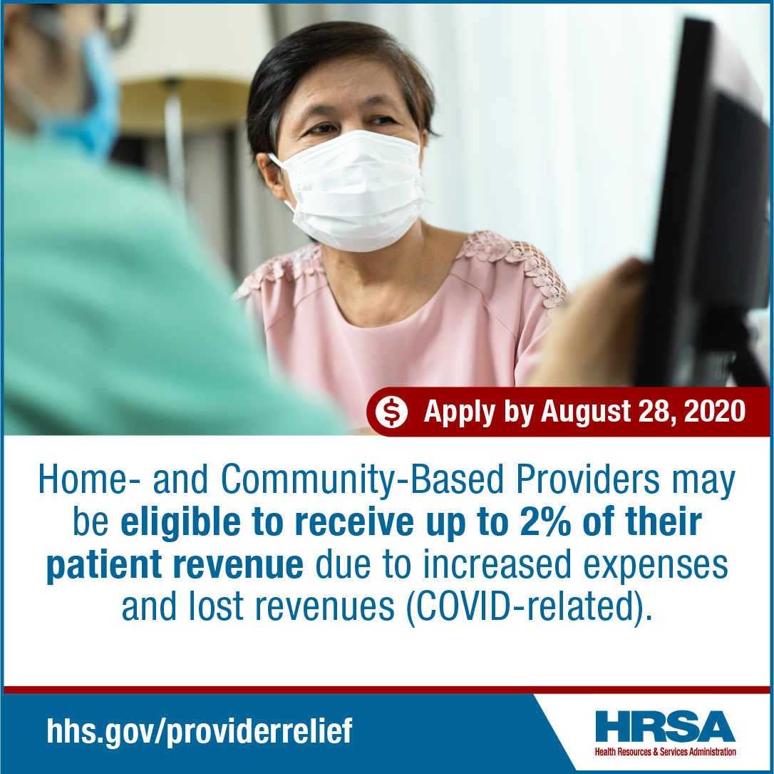

Dental
Dental providers may be eligible to receive up to 2% of your patient revenue from the #providerrelieffund. Received funds already but missed your opportunity to apply for additional funding up to 2% of revenue? You may have another chance. Find out more and apply by August 28, 2020. bit.ly/30zECa5 #Dentalproviders #Dentalpractices

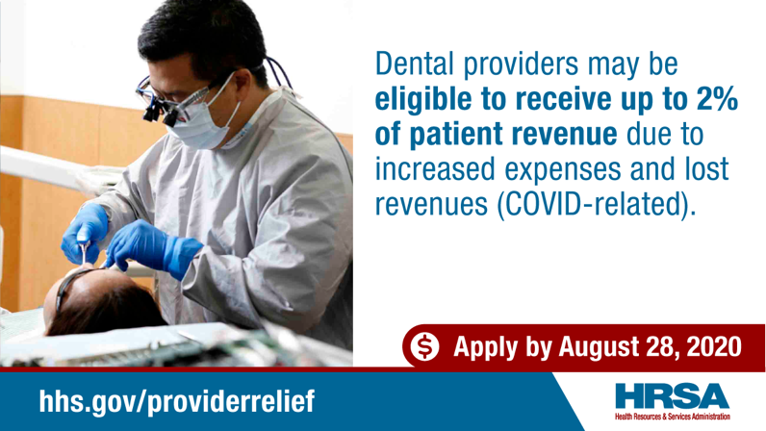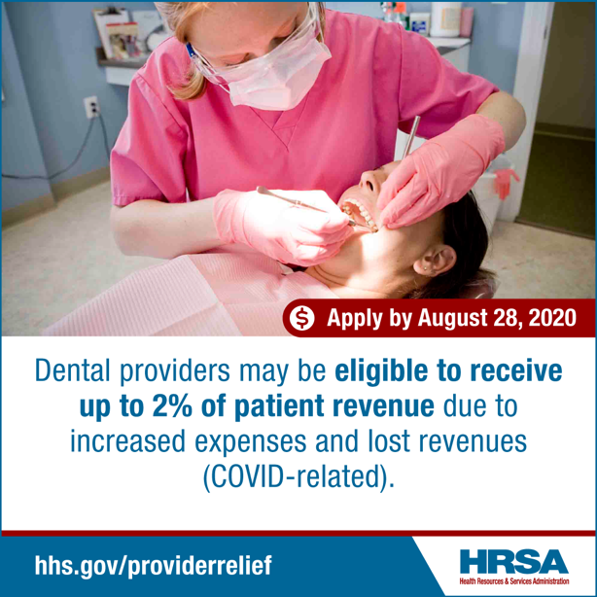

Webcast Announcement
Attend a webcast on Thurs., Aug 13 at 3:00pm ET about the CARES Act Provider Relief Fund. Learn about the expanded application and who is eligible to apply. Register now to save your spot: https://bit.ly/3fIlD2w #providerrelieffund #Medicare #Medicaid #CHIP #Dental
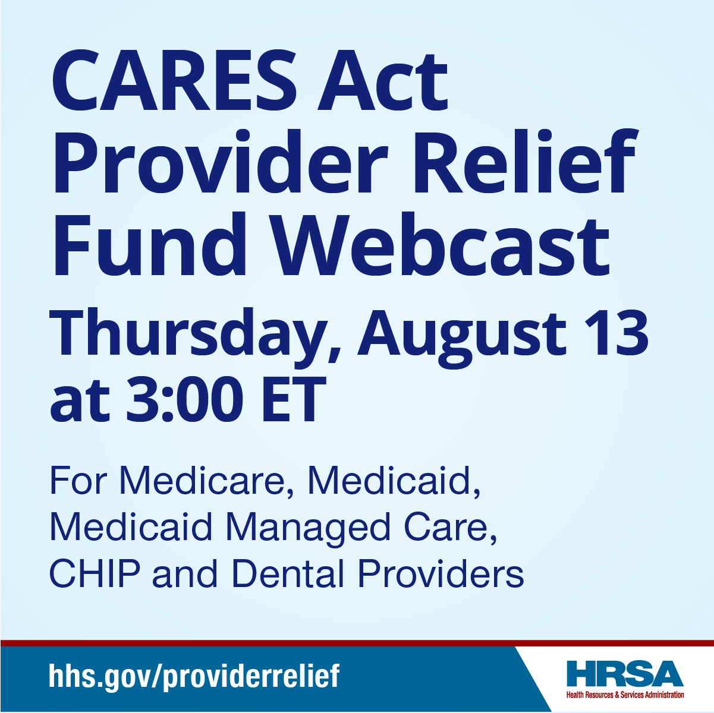
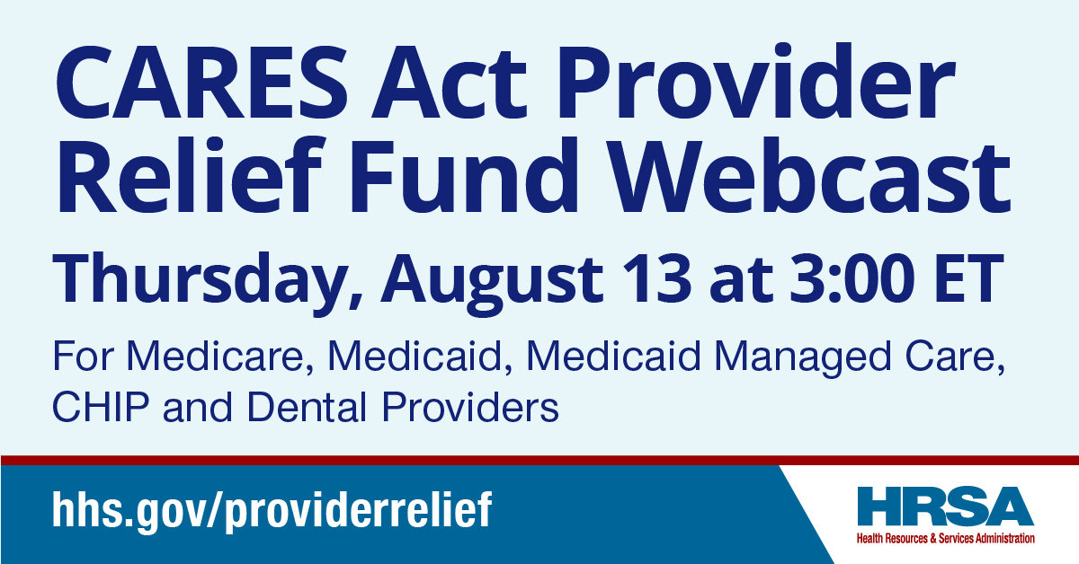

###

Sample Newsletter Content
FINANCIAL SUPPORT FOR MILLIONS OF HEALTH CARE PROVIDERS NATIONWIDE
Up to 2% of patient revenue regardless of a previous disbursement.
Many health care providers are experiencing significant financial hardships in the COVID-19 pandemic. Congress provided $175 billion in relief funds to the U.S. Department of Health and Human Services (HHS) to deliver financial relief to hospitals and other health care providers, including those on the front lines of the coronavirus response. The latest phase of funding is now available through August 28, 2020. Those who bill Medicare, Medicaid, Medicaid Managed Care, CHIP, or a dental provider are eligible to apply as long as they haven’t already received 2% of their patient revenue from the fund. Visit hhs.gov/providerrelief and register for the webcast on Aug. 13 at 3pm ET.

###

